Data Entry Standards: Jenzabar EX

Southern Wesleyan University
Revised October 6, 2015

OVERVIEW
This document has been compiled to address common standards to which all departments must adhere when entering or changing data in the Jenzabar EX application or database. It does not address data entry standards in any other applications apart from the Jenzabar EX application. Department-specific standards must comply with the standards presented in this document, and will be maintained separately from this text. The document pertains to any employee responsible for entry or maintenance of data in the Jenzabar EX application.
Common “modules” addressed herein:
      - Duplicates
      - Name
      - Address
      - Biograph
      - Notepad
      - Attributes
      - General
      - Relationships
This document and its standards will be reviewed annually at the end of the academic year (June), and as needed relating to major upgrades, etc. The text will be reviewed by the Data Entry Standards Sub-Committee and approved by Modules Managers.

Section 2 – Duplicates
    - Before entering any person or business into the database, carefully check to make sure that the entity you are entering is not already in the system. (See the section on “Duplicates” for details.)
      - Duplicate Example 1: There are three records for one person with different variations in the spelling of their first name (Christine, Christina, and Christie), but they are all the same person.
      - Duplicate Example 2: If the first name you get is a derivative of a name (e.g., Bob instead of Robert, Liz instead of Elizabeth, etc.) check to see if someone in the system has the full version of that name in your search for duplicates.

Section 3 - Name (Individual or Business/Organization)
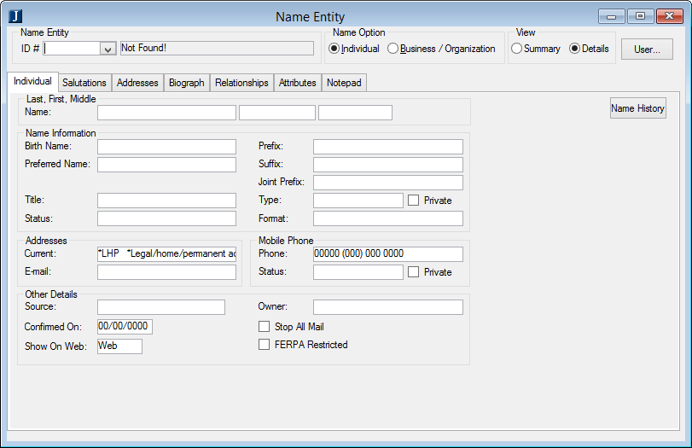
- Individual Tab (refers to people NOT business/organization)
    - Name Information Section
      - Last, First, Middle Name
        - Enter the full legal name as it would appear on the person’s Social Security Card.
          - Do not enter preferred names or nicknames in these fields—legal name only.
          - Do not enter Suffix or Prefix in these fields. (Use the designated fields for these.)
NOTE: The legal name is used for password resets and other verification, so it is important that this data is entered correctly.
        - Punctuation Rules.
          - Only use a hyphen and/or apostrophe when it is included in the legal name.
          - Do not enter a period (“.”) in any name field for individuals (i.e. middle initial).
        - Middle name should be full middle name to help prevent duplicate records. If no full middle name is provided, enter the initial only.
        - International Student Rules.
          - Enter full legal name as it would appear on the person’s passport, green card, or other legal document
          - Last name = Surname
          - First name = Given Name – including middle if characters allow
          - Middle name = subsequent names in Given name that will not fit in First Name field
          - Enter a note in notepad with person’s legal name from Passport for reference

NOTE: The name in PowerFAIDS overrides the name in Jenzabar when transferred from PowerFAIDS to Jenzabar.
- Individual Tab (continued…)
      - Birth Name
        - Enter the Maiden Name of the person.
      - Preferred Name
        - NOTE: This is a KEY field for creating student and other accounts. The Preferred Name is part of the person’s account ID as well as the person’s email address.
          - Account Names follow the standard of PreferredName+LastName (e.g., “AlexSmith”, “MaryJones”).
          - Email Addresses follow the same standard with “@mail.swu.edu” appended.
        - If a person wishes to go by a name other than his or her legal first name, the First Name field must still contain their legal first name and only that.
The Preferred Name field is where other names go.
        - No Preferred Name Specified
          - If a preferred name has not been provided, enter the first name into the Preferred Name field. (Required)
        - Derivative Name
          - If any person wishes to go by a derivative of their legal first name (e.g., “Rick” instead of “Richard”):
            - Enter his or her entire legal first name into the First Name field.
            - Enter the preferred derivative name in the Preferred Name fields.
        - Middle Name
          - If any person wishes to go by their middle name:
            - Enter his or her entire legal first name into the First Name field.
            - Enter his or her middle name into both the Middle Name and Preferred Name fields.
        - Last Name
          - If any person wishes to go by their last name:
            - Enter his or her entire legal last name in the Last Name field.
            - Enter his or her first name in the Preferred Name field.
            - Enter his or her last name in the Nickname field.
NOTE: The Nickname field appears to have been removed from the Name tab. Was there a reason for this?
        - Indistinguishable/Inappropriate Names
          - If a person wishes to go by a name that is not a distinguishable part of their legal name (e.g., “Bubba” or “G-Dog” unless that is their real name), that name should only be entered in the Nickname field. It is not fit to be entered into either their First Name or their Preferred Name field.
        - Examples
          - Robert Smith prefers “Bob”
            - First name = Robert
            - Preferred Name = Bob
            - Last Name = Smith
          - John Paul Pennington prefers “Paul”
            - First Name = John
            - Middle Name = Paul
            - Last Name = Pennington
            - Preferred Name = Paul
          - John T. Doe prefers “JT Doe”
            - First name = John
            - Middle Name = T
            - Last Name = Doe
            - Preferred Name = JT.
          - Elizabeth Jones prefers “Baby”
            - First name = Elizabeth
            - Last Name = Jones
            - Preferred Name = Elizabeth
              - DO NOT put “Baby” in Preferred Name. (We aren't going to send mail to a nickname like “Baby.”)
            - Nickname = Baby
      - Title (optional)
        - There is no validation on this field, and it is currently not used.
      - Status
        - Enter “C” as the default (Presumed Current).
        - Other value is “O” (Out of Date).
          - Is this used to indicate an inactive person?
      - Prefix (Required)
        - Do not enter a period (“.”) in the prefix.
        - Prefixes are only to be entered into this field—never in the First or Last Name fields.
      - Suffix (optional)
        - Do not enter a period (“.”) in the suffix.
        - Suffixes are only to be entered into this field—never in the First or Last Name fields.
      - Joint Prefix
        - Used by Advancement and for Parent records.
      - Type
        - If known, please select the appropriate value. Currently only used by Human Resources.
      - Private
        - ?
      - Format
        - Select “M” as the default for individuals (Personal / Middle Initial name format).
          - ??? Name Format should be entered according to that person’s preference???
NOTE: If a person changes, for example, from a donor to a student, DO NOT ERASE DATA!
    - Addresses Section
      - Current
        - This is “*LHP” by default.
        - Not being used?
      - Email
        - This defaults to the “*EML” (Primary) email address entered in the Addresses tab.
    - Mobile Phone Section
      - Phone
        - Enter the mobile phone number of the individual, including area code.
        - What about international numbers?
      - Status
        - This is “A” by default (Active).
        - Other option is “I” (Inactive).
          - Is this used?
      - Private
        - ?
    - Other Details Section
      - Source
        - Not used?
        - What is this? (Current options are “1”, “4”, “D”, “M” and “S”.)
      - Confirmed On
        - Defaults to the current date.
      - Show on Web
        - This is “Web” by default.
          - Is there ever an appropriate time to choose “None?”
        - Options
          - Web – Web access for Students and Faculty – CRM portlets only
          - None – No Web access
      - Owner
        - This should be the department abbreviation of the employee entering the data.
        - Example: If Admissions is entering the data, this should be “AD”.
      - Stop All Mail
        - The owner of the record (see “Owner” above) is responsible for checking or unchecking this field.
        - This field applies to ALL mail for this person.
          - Only use this field for individuals who are requesting to never be contacted again.
          - If an individual requests a particular type of contact to be stopped, use the appropriate departmental “stop mail” flag instead of this one (e.g., stop mail only from Advancement).
        - Everyone must look at this column when sending correspondence, to make sure individuals with this field set to “Y” are excluded from the mailing!
      - FERPA Restricted
        - (a) All information contained in a student’s education record is FERPA protected with the exception of directory information. Directory information may be released to a third party without the student’s written consent except for when the student requests that such disclosure be prohibited. This check box indicates a student’s submitted request to prohibit disclosure of his or her directory information to a third party.
        - When the check box is selected (= “Y”), the student has submitted a written request to the Office of Academic Records to protect his or her directory information from disclosure to a third party. School officials may still access protected directory information for their own purpose according to their job duties and legitimate educational interest, but disclosure to a third party is not permitted.
        - If the check box is cleared (= “N”) the student’s directory information may be released to a third party without written permission from the student. The default value is “N”.
        - SWU has designated the following as directory information:
          - Student’s name
          - Local and permanent address
          - Telephone number
          - Date and place of birth
          - Major field of study
          - Dates of attendance
          - Degrees and awards (including scholarships) received
          - Participation in officially recognized activities and sports
          - Weight and height of members of an athletic team

  - Churches / Organizations
    - To be discussed….

  - Name Changes
    - To be discussed….
      - Reasons
      - Process
      - Acceptable Proof of Name Change
      - Other Name Change Issues
      - Other?
- Addresses
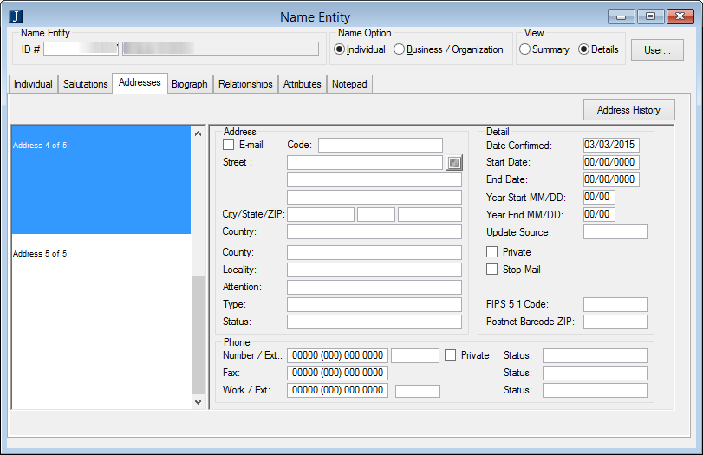
  - General
    - Addresses are to be typed using Proper Case.
    - Addresses are never to be typed in all upper case or all lowercase.
    - No punctuation should be included except for hyphens and apostrophes when part of the proper name (street, city, etc.).
    - Everything should be spelled out properly; there should be no abbreviations in addresses anywhere.
      - Exception: “Post Office Box” should be abbreviated to “PO Box”.
    - When adding a new address record, please be sure to use the Add Row function for the new address. Do not overwrite an existing address!

  - People (Individuals)
    - Address Section
      - Email checkbox
        - Check this box if the address being entered is simply an email address.
      - Code
        - Select the appropriate address code for the address being entered.
          - Common codes used:
            - *LHP – Legal Home Permanent: The person’s legal place of residence
              - NOTE: Every person should have a *LHP address (required), not just a summer address, parent’s address, etc.
            - *EML – Primary Email Address:
              - This is to store a person or business’s preferred or first email address.
              - If the person is a student, staff, or faculty of SWU, this MUST contain their SWU email address. NO EXCEPTIONS.
        - This field needs further discussion regarding valid entries, used/unused entries, etc.
      - Street
        - Divided into three fields: Address Line 1, Address Line 2, Address Line 3
          - Address 1
            - Street Address only, unless there is only a PO Box for an address
          - Address 2
            - PO Box if it is the only item included with a street address, OR…
            - Apt/Suite/Lot # if both a street address and a PO Box are included
          - Address 3
            - PO Box if both a street address and Apt/Suite/Lot # are included
        - Example 1
          - Address 1 Street Address 123 Main Street
          - Address 2 PO Box PO Box 87
          - Address 3 (left blank)
        - Example 2
          - Address 1 PO Box PO Box 123
          - Address 2 (left blank)
          - Address 3 (left blank)
        - Example 3
          - Address 1 Street Address 123 Main Street
          - Address 2 Apt # / Suite # / Lot # Apartment 4B
          - Address 3 PO Box PO Box 44
        - Example 4
          - Address 1 Street Address 1000 Rural Lane
          - Address 2 Apt # / Suite # / Lot # Lot 27
          - Address 3 (left blank)
      - City
        - Enter the full name of the city (no abbreviations).
      - State
        - Select the correct state from the drop-down menu.
      - ZIP
        - The 5-digit ZIP code should be used at a minimum.
        - If available enter the ZIP+4 code.
          - Format: 5 digits + hyphen + 4 digits (e.g., 12345-0001)
          - The ZIP+4 code is preferred in general, and is required for Development.
        - ZIP+4 may be required for bulk mailings. (RESEARCH THIS.)
      - Country
        - Select the correct country from the drop-down list.
        - This is required for ALL legal/mailing addresses (including US addresses).
NOTE: Need to come back and address International student names.
      - County
        - Select counties for South Carolina addresses only.
        - For non-South Carolina addresses, select the appropriate non-South Carolina county in the EX address. (This is a change from the previous procedure.)
          - You can look up the county for the address at https://tools.usps.com/go/ZipLookupAction_input, then
Currently, the online applications are designed to only allow applicants to select “96 Not SC” if a non-SC state is selected.
The applications need to be changed to allow non-South-Carolina counties to be selected.
Will investigate prefilling the county based on the ZIP code entered.
      - Locality
        - Not used?
      - Attention
        - Admissions uses this for PGDN addresses for names of parents.
          - Is this used by any other departments?
        - Format follows standard specified for names (capitalization, punctuation, etc.).
Address Line 3 (ADDR3) is used for PGDN email addresses currently. This needs to be in a separate code/address record.
Module Managers need to address parent records and FERPA entry.
      - Type
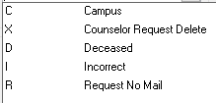
We discussed eliminating all of the above Type codes except for possibly “D Deceased".
        - Admissions is currently using “Deceased”.
          - Continue to use?
Possibly add a “deceased” stage code? Re-purpose stage code 99?
      - Status
        - Use in coordination with “Stop Mail” field to help explain why mail is stopped.
        - Codes
          - M – Mail Returned
          - N – obsolete
          - O – obsolete
          - C – Presumed current – Choose this as the default.
          - R – Requested removal / Opted Out
          - Add Deceased?
    - Detail Section
      - Date Confirmed
        - This date defaults to the current date when a new address is entered.
        - Always update this date when updating an address.
      - Start Date
        - Optional – If used, reports must include or filter this column.
      - End Date
        - Optional – If used, reports must include or filter this column.
      - Year Start MM/DD
        - Optional – If used, reports must include or filter this column.
      - Year End MM/DD
        - Optional – If used, reports must include or filter this column.
      - Update Source
        - Optional, not currently used.
        - Need to revisit this to make use of it.
      - Private
        - Not currently used.
      - Stop Mail

      - FIPS 5 1 Code
        - Not currently used.
      - Postnet Barcode ZIP
        - Not currently used.
    - Phone Section
Note: The mobile phone number should be entered on the Name/Individual tab.
      - Number / Ext
        - This is for the home phone number.
        - If only a mobile number was provided, enter that number here as well as on the Name/Individual tab.
      - Private
      - Fax
      - Work / Ext
      - Status (one each for Phone, Fax and Work)
        - A – Active
        - I – Inactive

Copied and adapted from the CCU Standards document:

  - Business/Organizations
    - To be discussed….

  - Address Codes Defined
    - “*” Address Codes
      - These are some of the most important codes we use on a daily basis.
      - *LHP – Legal Home Permanent
        - Used for personal home addresses and for businesses as their main address.
      - *EML – Primary Email
        - This is to store a person or business’s preferred or first email address.
        - If the person is a student, staff, or faculty of SWU, this MUST contain their SWU email address. NO EXCEPTIONS.
      - *WRK – Work Address
        - This has been used inappropriately to record the employer of the person, rather than their work address.
        - We need to change the way we capture employer information by setting up entities and relationships.
          - Once we get this cleaned up, we will want to record employer information in the Biograph tab—not here.
      - *CUR – Current
        - THIS CODE IS NOT TO BE USED TO DEFINE AN ADDRESS.
        - It is only to be used on certain screens to specify that a particular address, be it *LHP or PLCL, is their current preferred address at which to receive information.
    - Physical Address Codes
There are 4 main types of physical address codes: those for persons, businesses, our internal use, and organizations.
      - Person
        - *LHP – A person’s legal place of residence
        - PCMP – A person’s campus address – Student Life uses another column?
        - PDRM – A person’s dorm address – Student Life uses another column?
        - PEMG – An emergency contact address – Student Life uses another column?
        - PFTH – A person’s father’s address – not used
        - PGDN – A person’s legal guardian’s address
        - PGD2 – A person’s legal guardian’s address
        - PLCL – An international student’s local or host family address – Using *LHP?
        - PMTH – A person’s mother’s address – not used
        - PSMR – A person’s summer address – not used
        - PSWK – A person’s spouse’s work address – not used
        - PVCN – A person’s vacation address – not used
        - PWK – A person’s work address – not used
        - PWTR – A person’s winter address – not used
        - BINV – A billing address. – not used
        - A001 – Alternate mailing address – Used by the Business Office
        - A002 – Alternate mailing address – Used by the Business Office
      - Business
        - *LHP – A business’ primary / main office address
        - BALT – A business’ alternate address
        - BCHK – A business’ Accounts Receivable address (aka, Check Address)
        - BINV – A business’ Accounts Payable address (aka, Invoice address)
        - BPO – A business’ Purchase Order address (aka, Ordering Address)
        - BSHP – A business’ Shipping address
      - Internal
        - IFTR – Financial Aid Transcript return address – not used
        - IMGN – “Our mag media address” – not used
        - IRCT – Receipt Return address – not used
        - IRTN – Our Return address – not used
        - IRTR – Transcript Return address – not used
      - Organization
        - *LHP – An organization’s primary / main office address
        - CHPL – Church physical address
        - OBRC – An organization’s branch address (not the main office) – not used
        - OCMP – An organization’s campus address – not used
        - OLCL – An organization’s local address – not used
        - ONTL – An organization’s national address – not used
        - ORGL – An organization’s regional address – not used
        - OSTT – An organization’s state address – not used
    - Email / Electronic Address Codes
      - *EML – Primary Email – This is to store a person or business’s preferred or first email address. If the person is a student, staff, or faculty of CCU, this MUST contain their SWU email address. No exceptions.
      - *SWU – Lifetime Email – This is to store a student’s lifetime email address. DO NOT MODIFY.
        - Is this still valid?
      - EML2 – Secondary Email – This is to store a person or business’s secondary email address.
      - EMLB – Business Email – This is to store a business’s email address.
      - TEML – Tertiary Email – This is to store a person or business’s tertiary email address. – not used
  - Stop Mail Flags
    - Need to discuss more fully.

- Biograph
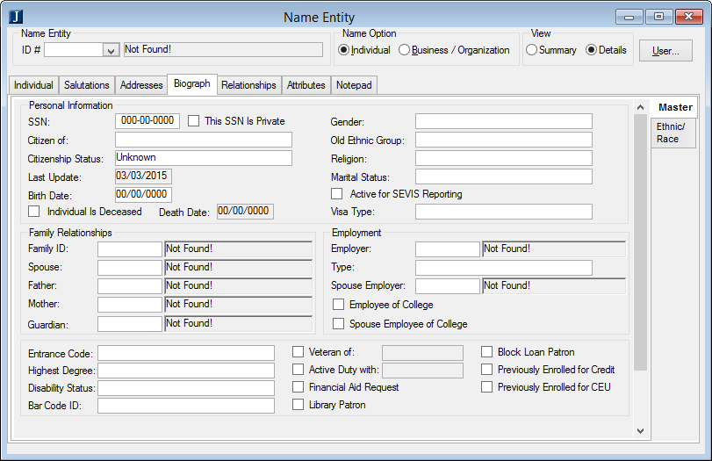
  - General

  - People (Individuals)
    - The Biograph tab only applies to individuals—not to businesses or organizations.
    - Master Sub-Tab – Personal Information Section
      - SSN
        - Entered by Admissions for candidates
        - Required for all:
          - Employees
          - Prospective Students applying for Financial Aid
          - Accepted Students
          - Enrolled Students
          - Vendors
          - Employers ????
        - If any of the above refuse to provide their SSN, after repeated attempts, Financial Aid is responsible for a SWU-provided SSN.
        - Every attempt should be made to collect the SSN.
      - SSN Private – This should always be checked (true).
      - Citizen of – Required. Enter/select “ZZ” if unknown.
      - Citizenship Status
        - Required
        - Must specify either “Unknown” or the correct citizenship status from the drop-down list.
          - Resident Alien – Green card holder
          - Nonresident Alien – Temporary visa holder
          - Who verifies these?
      - Last Update – Auto-filled
      - Birth Date
        - Required for all:
          - Employees
          - Prospective Students applying for Financial Aid
          - Accepted Students
          - Enrolled Students
          - Vendors
          - Employers ????
        - Every attempt should be made to collect the birth date.
Janice Hartsoe was investigating whether or not we can require SSN and Birth Date on applications.
      - Individual Is Deceased
        - This is the primary column used to note that an individual is deceased.
        - The data owner is responsible for updating this column.
        - NOTE: Follow the procedure for marking an individual as deceased. (There is more to marking an individual as deceased than just checking this box.)
          - TO BE DEVELOPED!
            - e.g., find obituary online and print for documentation once notified.
            - e.g., employee vs. alumni process
      - Death Date
        - Required if “Deceased” is checked (true).
        - If correct date is unknown, enter 01/01/1900. (You can just enter 1900.)
*** Add an action code for “deceased” ?
Pull over the action code, and update the details in the notepad entry about how you found out
that the individual is deceased.
      - Gender
        - Required
        - Choose one:
          - F – Female
          - M – Male
          - N – Not Reported
      - Ethnic Group – Obsolete (removed)
      - Religion
        - Required
        - Choose “Not Reported” if unknown.
      - Marital Status – Required
      - Active for SEVIS Reporting
        - Required for all international students
        - Used by Admissions and Student Services
      - Visa Type – Required for all Resident Aliens and Nonresident Aliens
    - Master Sub-Tab – Family Relationships Section
      - Family ID
        - Groups household / address together (head of household)
        - Used by Development to limit mailings
      - Spouse – Enter ID number if known.
      - Father – Enter ID number if known.
      - Mother – Enter ID number if known.
      - Guardian – Enter ID number if known.
    - Master Sub-Tab – Employment Section
These columns are entered by Alumni.
      - Employer – Enter ID number of employer business/organization.
      - Type
        - Used to indicate whether an individual is employed in his/her field of study
        - N – Not working in field of study
        - Y – Working in field of study
      - Spouse employer – Enter ID number of spouse’s employer business/organization.
      - Employee of College – Check this box if the individual is employed by SWU.
      - Spouse Employee of College – Check this box if the individual’s spouse is employed by SWU.
    - Master Sub-Tab – Last Section
      - Entrance Code – Not currently being used
      - Highest Degree – Not currently being used
      - Disability Status – Not currently being used
      - Bar Code ID – Not currently being used
      - Veteran of
        - Admissions, Registration and Development use this.
        - Check the box, then select from the drop-down list to select the appropriate branch.
      - Active Duty with
        - Admissions, Registration and Development use this.
        - Check the box, then select from the drop-down list to select the appropriate branch.
      - Financial Aid Request – Not used
      - Library Patron – Not used
      - Block Loan Patron – Not used
      - Previously Enrolled for Credit – Not used
      - Previously Enrolled for CEU – Not used
    - Ethnic/Race Sub-Tab
      - This is required information that is collected by Admissions and Payroll.

- Relationships
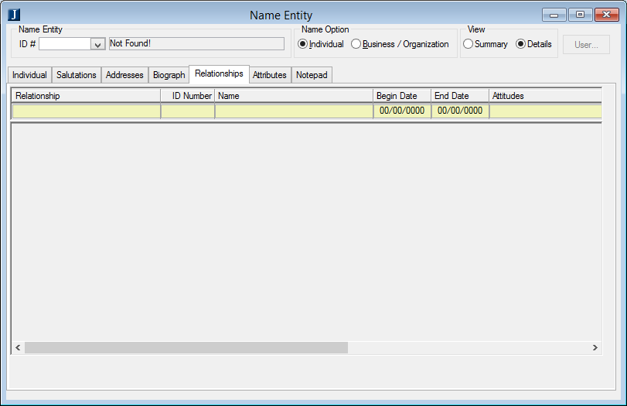
  - General
    - Do not delete relationships!
      - If a relationship no longer exists, edit the row and add an end date.
      - If a relationship has been replaced, edit the row and add an end date, and add a new row for the new relationship.
    - Relationship entry begins in Admissions when collecting information about candidates.
      - This is important for FERPA.
    - What groups do we want to track?
      - Enrolled Students (= Alumni)
      - Businesses
      - Churches
      - Parents
      - Employees/Trustees
      - Constituents (Donor/Friend)
      - Schools/Universities
    - Relationships are self-reported. We make entries and changes based on what individuals report to us.
    - Ownership of relationship entities
      - Enrolled Students (= Alumni)
      - Businesses Need to go through Dev/BO
      - Churches
      - Parents
      - Employees/Trustees
      - Constituents (Donor/Friend)
      - Schools/Universities Admissions

    - PICK UP HERE

  - People (Individuals)

- Attributes
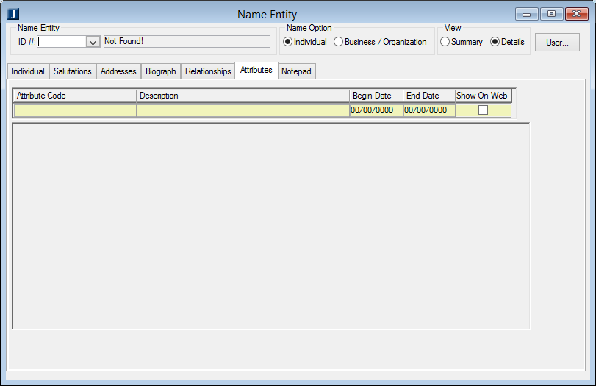
  - General
    - Do not delete attributes!
      - If an attribute no longer applies, edit the row and add an end date.
      - If a attribute has been replaced, edit the row and add an end date, and add a new row for the new attribute.
    - Attributes are used to group people together.
    - If you create a new attribute:
      - Bring the information to the next Module Managers meeting.
      - Notify……………………

  - People (Individuals)

Section 8 – General
    - To be discussed….
  - Please review this section, copied from CCU Standards document:
    - Always double check name spellings.
    - Names are to be typed using Proper case.
    - Names are never to be typed in all upper case or all lowercase.
      - EXCEPTION: A business whose name is an acronym (e.g., AARP).
    - Punctuation
      - Names are only to have punctuation when it is part of their legal name.
      - Names are never to be entered with periods, even when it is an initial.
      - Hyphens and apostrophes are acceptable.
      - Names are never to be entered with diacritical marks.
        - Examples: ä, á, ą, ć, ç, é, ê, í, ü, or any other accent marks not listed here
    - Name Format should be entered according to that person’s preference.
Proper Case Example: Entry of names like “McCloud” or “MacHenry”?

