Southern Wesleyan University

Database Instructions

and

Procedures Manual

Last revised January 26, 2011

Prepared by the Jenzabar subcommittee
Joy Bryant, Chair | Rhonda Bracken | Joan Crain | Mark Mealy
Mary Andrews | Devon Broome | Dana Frost | Winnie Molloseau
Tonda Bagwell | Pam Burnett | Nikki Hanson | Mike Preusz
Regina Bolding | Melissa Childs | Vicki Hayes | LeaAnn Thompson
Nancy Boone | Mary Costello | Rock McCaskill | Donna Wood

Southern Wesleyan

Database Instructions and Procedures

page

*in order by level of difficulty
Searching Jenzabar 2
Formatting Jenzabar 3
E-mail 4
Record Updates 5
Births 10
Attributes 11
Business/New Employment 12
Stop Mail/Receive Mailings/Returned Mail 13
Notepad 15
Relationships 22
DUP - Records 25
Retired 26
Creating a New Record 27
Married & Divorced 31
Deceased 33
Family ID Information 38
TRUSTEE records 39
Searching Jenzabar
Quick Name Search
Quick Name Search allows you to quickly associate an ID Number and Name by providing information about the name entity so that you can select the correct ID Number without leaving the window in which you are working.
Note: You do not have to enter entire names in the id number field to search. You can enter a portion of the names separated by a comma. Ex.: You can enter Smi,Jo to look up all last names that begin with Smi and have a first name beginning with Jo. Click on the drop down arrow to see names retrieved.
You can execute the Quick Name Search by entering known information in any ID Number column according to the following rules and then clicking on the drop down arrow.
- Enter all or part of the Last Name
- Enter the Last Name and First Name. The Last Name must be followed by a comma, optional space, and First Name. (Ex. Smith, John or Smith, John)
- Enter the individual’s SSN in ###-##-#### format.
- Enter the individual’s Birth Date in MM/DD/YYYY
- Enter a Zip Code. Include a single or double quotation mark in front of the Zip Code (Ex. “29630)

Other possible searches in the id number field:
Smi- find names beginning with smi for example like smith
%Smi-find names that contain smi like Myers-Smith hyphenated name %, Monica-find all names with first name = Monica %, %ess- find names with ess in first name like Tess and Jessica
M, %ob-find names with last beginning with M and first names with ob in them which provide for Robert and Bob and Rob names
W, ‘29630- find names with all last names beginning with W and in zip code 29630
W, 9/25/1967- find all names with last beginning with W and DOB. Very nice but wish you didn’t have to enter a year. You must enter the whole date.
The system always wildcards to the right hand side of the characters.

Formatting for Jenzabar
Spell out everything in an address line- Some exceptions are Inc., PO Box and Corp.

Spell out all directions- North, South, East, West, Northeast, Southeast, Northwest, Southwest
NOT- N N. NE N.E. North East

Some examples of words that are often abbreviated but should be spelled out.
Saint Mount Fort Point
Street Drive Avenue Circle
Parkway Highway Place Plaza
Road Boulevard Lane Court
Company County University State Road
Community Department School County Road

Also spell out state names if they are in the address lines. Unless name is too long then you can abbreviate the State but only if name is too long to fit in address lines.
Ex. Indiana Department of Education

PO Box (NOT: P O Box, P.O. Box, PO BOX, Post Office Box)
Place PO Box at the beginning of a new line, not at the end of a line.
Ex. 123 Lilac Lane
PO Box 456

APT, Suite, and Unit are to be placed on the third address line with Apartment, Suite, Unit spelled out.
Ex. ABC Corporation
123 North Highland Street,
Apartment 12B

Inc. is the correct abbreviation for Incorporated. Be sure to put a comma before Inc.
Ex. Business Name, Inc.

Rural Route needs to be spelled out (NOT RR, R.R., R R) (Post office are working on doing away with Rural Route, however at this time there are still some Rural Route addresses.
Do not include # before the number
If there is a Box that follows, be sure to put a comma to separate it.
Ex. Rural Route 1, Box 88
Other formatting information:
-If & is part of a business name, be sure to have a space before and after it (Ex. AT & T)
-If a single letter is part of someone’s name do not follow with a period. (William B Goodrich)
-Be sure to use the prefix drop down menu for all prefixes Dr. Jr. Mr. and Mrs.
-Do not use the number sign(#) anywhere in the address lines. It is often an abbreviation for APT, Suite or Unit.
You can enter the address on www.usps.com under the “Find a Zip Code” link to find out a zip code or confirm an address.
-In names of companies that begin with “The”, put it at the beginning of the name. (Ex. The Accounting Firm)

E-mail
Email instructions:

Bounced emails:
Hard bounce: Didn’t reach intended email
i.e., Email invalid, no known user, email account not valid, etc.
DELETE email address from record

Soft bounce: Didn’t reach intended email due to ‘temporary’ problem with their email account
i.e., Email box full, problem with server, temporarily unavailable, etc.
DO NOT DELETE email address, will try again on next mailing

Private requests: (means do not share with anyone i.e. alumni directory)
Check mark PRIVATE on *EML, EML2 or EMLB email address rows on address tab

Multiple email addresses: i.e Secondary address/Business address
Add a row in the address table. Enter second email address in EML2 address code. If business enter in EMLB address code(business email)

Parent of a prospective student/current student e-mail address
Uncheck the e-mail box on the primary e-mail address of the student record. Enter the parent e-mail address on address line 3. Check the e-mail box on the primary e-mail address prior to saving record.

Receive online communication:
YES then add email address if not already added to *EML or if multiple then to EML2 or EMLB as appropriate. Make sure stop mail is not checked on the specific address and change address status to presumed current.

Remove from email communication:
Select the appropriate e-mail address in the address tab. Check the” stop mail” field on the e-mail address. Change address status to “requested removal/Opted out”. Change date confirmed field to date constituent requested removal. If unknown, set to date record modified.

Do Not Solicit by e-mail:
See Development standards for removing a constituent from e-mail solicitations.

Department specific E-News Opt out:
As the University expands its e-mail solicitations and communications to constituents, more codes will be added to handle the opt in and opt out options per department/campaign. See development standards for information on how to manage an individual e-news/solicitation effort.

Record Updates

General Information and Standards

Make a note that all reports should pull with the field stop mail and deceased as part of the standard reports on all records.
Only update records owned by your department. If multiple departments are vested in a record then clear communication is essential with the owned department. Email notification is acceptable.
Notification of Data Updates:
HR Human Resource, notify Dana Frost
RE Academic Records/Current Students, notify Rock McCaskill
DE Development, notify Melissa Childs
AL Alumni, notify Joy Bryant
AD Admissions/Prospective Students, notify Donna Wood
AP Accounts Payable, notify Nancy Boone

Types of Data Updates Received:
- Update Information Forms (online)
- Email bounce backs and responses (emails)
- Postal returns
- Interdepartmental updates (emails, notes or forms)
- Alumni Office i.e. bio sheets, address changes, email bounces/responses, general updates
- Registrar Office i.e. parent updates
- Annual Giving Office i.e. phonathon updates, address changes, general updates
- Planned Giving Office i.e. death notifications, general updates, address changes

General Updates-Instructions
Enter ID # in the Work with Relationships Screen (Right Click ‘tree’ to make selections)

Biographical Information
Name Tab
- Name: last name, first name, middle name
- Name Information: SEE SPECIFIC INSTRUCTIONS FOR MARRIED/DIVORCED RECORDS!!!
  - Add the maiden/birth name if known; add preferred name if known
  - Do NOT put a maiden name in the Middle Name field, even if record holder requests it because it affects the Registrar’s transcript procedures. You can accommodate the request with salutations!
- Prefixes: Add appropriate (example: Mr. or Mrs.)make sure it matches the salutations!!!!
- Joint Prefixes: Only add Mr. and Mrs. on an account if both have records in Jenzabar. If the person is the only one in the database, the joint prefix is the same as the prefix.
- Suffixes: Only things such as II, III, IV, Jr. and Sr. are to be used. Do not use other codes in this field.
- Addresses Current: change to DEA when deceased record instead of a *LHP address (SEE SPECIFIC INSTRUCTIONS FOR Deceased records!!! Can be *EML if only e-mail address or CHK if AP record.
- E-mail (priority): Don’t enter e-mails here. See instructions in the address tab
- Mobile Phone: Only place to enter a cellular phone number. If used as primary #, list in *LHP too and make notepad entry listing home number if known.

Stop All Mail:
Enter check mark to STOP ALL MAIL on ALL deceased records. For specific stop all mail requests place notepad entry with information. See notepad entry for specific instructions.

Address Tab
Address/Phone Boxes:
- Select ‘row’ to update i.e. *LHP, *EML, BUS, EM2, etc
- To Add a New Row (BUS, *EML, EM2, etc.): Right click on address tab and click ‘Add Row’.
- *EML and EM2: See Email Section for specific instructions regarding email kickbacks and updates!!
  - If there is only an EM2 and there is an update, delete the EM2 and put the e-mail as the *EML
- Update information as needed i.e. street, city/state/zip, country. County: DO NOT REMOVE or change!
  - Only update information provided. If PHONE or BUSINESS not updated, LEAVE OLD INFO in record!
- Attention: Use for e-mail addresses of shared records spouse or parent as needed.
  - For example “Sue’s e-mail”.
- Status: P for Postal Return or L for Lost *See Returned Mail for more specific instructions!
- Phone Number/Ext./ Fax: Enter the extension in the box in between number and the private check box.
Details Box:
- Add date confirmed when update is made!!
- Year Start End MM/DD: Only use for Summer/Winter addresses.
- Update Source: Enter I for update received from individual or P for update received from postal return
- Private: Check the box if the person requests their information to be private. Make notepad entry of request

Biographical Tab
Personal Information:
- Social Security Number-Enter if provided
- Gender: Enter if known
- Religion: Enter if known
- Marital Status: SEE SPECIFIC INSTRUCTIONS FOR MAKING A MARRIED OR DIVORCED RECORD!!!
  - Change as needed (Married, Divorced, Widowed, Unknown, etc.)
  - Do not enter single when people get a divorce. Add the Divorced status.
- Birth Date: Enter if known
- Deceased- SEE SPECIFIC INSTRUCTIONS FOR MARKING A DECEASED RECORD!!!!!
  - MUST HAVE date of death (abbreviated DOD) If date of death is not known, try to look it up at http://ssdi.rootsweb.com. If you cannot find it there, look at local newspapers online where they lived otherwise double check with Assistant if you can’t find a date of death and ask if should use 01/01/00.
Family Relationships:
- Family ID= Owner Record
  - If both spouses are alums or has a record then the family ID goes to the male ID number
- Spouse ID=Spouse record ONLY if alumni
  - If deceased record then make record holder family ID and delete spouse ID
Employment and other information on this screen is not used by Development Services.
HR uses ‘Employee of College’ to indicate current employees. Use as reference for HR record updates.

Dev Bio 1 and 2 Tabs
Dev Bio 1:
- Career Type: DO NOT enter Career code for STUDENTS!
- Degree Type: Drop down box-Enter career field of work if known
- Class/Reunion Year: Change if alumni requests to reunion with a different class year. Make notepad entry
- Actual Grad Year: DO NOT CHANGE. This information has to coordinate with Registrar’s Degree History.

Dev Bio 2:
NEW EMPLOYMENT INFORMATION to Update (NOT OUR EMPLOYEES) *See HR RECORD UPDATE FOR MORE INFO
- Job Title: Type information as provided and as space allows; abbreviations allowed.
  - HR RECORDS: Job Titles are listed as Notepad entries with start and end dates
  - If retired, add the word “Retired” in front of the job title
- Solicitor: Remove Solicitor ID number on deceased records (SEE SPECIFIC INSTRUCTIONS FOR DECEASED)

Don’t forget when updating employer information to add or remove relationship of employers!! The relationship creates a matching gift reminder which in this case is not needed.

HR RECORD UPDATE – INSTRUCTIONS *Update ONLY if told by Assistant or Director!!
Do not change any information in NAME and ADDRESS tabs!!!!!
Notify HR of changes that need to be made to the record by their office.
HR Records maintained by Dana Frost
Only update information below for NEW employees or TERMINATED employees or CLEANUP projects!!
- Add or remove job title on DEV BIO2 tab
- Add or remove job class on DEV BIO1 tab
- Make sure family ID entered on BIOGRAPHICAL tab
- Add or remove giving relationship of current employee/faculty, former employee/faculty, etc. as appropriate or instructed.
- Add or remove salutations as needed
RETIRED updates
  - If told that you can update the record, be sure to check if there is a family ID and if the person has correct prefix and joint prefix (INF, FRM, LBL). Do not change over the record from HR to DE!
  - Change giving relationship default to Retired or Emeritus by adding row. Do not delete the other giving relationship(s). Make sure OF is added as giving relationship if not already listed.
  - Note: Default is hierarchy of closest relationship to the college
*See Giving Relationships for more information

Births
SEE ALSO SPECIFIC INFORMATION REGARDING ATTRIBUTES
- Right click on name and go to Attributes. Add a row and type in DCD01 as the code, hit tab, and type in the child’s name. If it is not their first child look to see how many children are listed in Attributes and then add a row with the code DCD0? (the question mark symbolizes what number the child is in the family).
- Add birthdate as begin date. If birthdate is unknown then enter UNK (case sensitive) and a space before the child’s name. Add 01/01/?? and birthyear, if you know their age.
- DO NOT do this for spouse record; ONLY put children on family ID record.

Attributes
Attributes (General) See Notepad for specific info!
Enter the name of the individual, organization, or ID number in the ID# field
Right click on the name of the record owner
Select attributes
Right click to Add Row OR Use the short-cut method of Ctrl+Shift+A
If the code is known type the code in the Attribute Code field
OR
If the code is not known, select the dropdown box by clicking on the down arrow.
Scroll down the list to find the code. Note: The Description will fill in automatically.
Enter in Begin Date, End date, for attributes that it would be appropriate such as for student athletes enter the academic year for beginning and the date for that year for ending. Note: if student participates in the same attribute a second, third or fourth year then only change the end date. If there is any lapse of time then create another attribute row. This will show if a student played a sport for two year, then dropped out of school for a year then returned for two more years. There would be two rows. One showing two years of beginning date- end date. Then a second row added to report the new beginning date-end date. Failure to do this will result in a student being perceived as participating for five years instead of four years with a one year break.
Attributes (Children/Stepchildren, Grandchildren, Great Grandchildren) DCD01…DSCD1…DCG01…or DCGG1
There are ten attributes set up initially for children, five for grandchildren and 3 for great grandchildren. More can be added if alum has more. The information recorded includes the attribute code, the name of the child, the birth date of the child and if necessary the death date of the child.

- Right click on name and go to Attributes. Add a row and type in the appropriate code, hit tab, and type in the child’s name. If it is not their first child look to see how many children are listed in Attributes and then add a row with the appropriate code/number.
- Add birthdate as begin date. If birthdate is unknown then enter UNK (case sensitive) and a space before the child’s name. Add 01/01/?? and birthyear, if you know their age.
- DO NOT add attributes to spouse records!! Only add to the family ID record holder! Will be added to spouse if divorced.
- Enter UNK first then comma space name i.e. as ‘UNK, name’ NOT ‘name, UNK’
- Don’t dup DCDO1 + stepkids

Business/Organization Records
Adding a New Organization or Business Record
There are two types of records on the Jenzabar system. There are records for individuals and records for Business/Organizations. Business/Organization records have a different format than individual records to accommodate the distinct type of information stored and retrieved about businesses and organizations.
Click once on New Name
Under Name Option click the Business/Organization radio button.
In the Business Name field enter the name of the business
In the Type field select O Organization from the drop-down box
In the Format field select B Business Name from the drop-down box
In the Owner field select DE Development, Alumni, Corporation, and Friends
Click the address tab
Enter the address information according to general update and postal standards
Enter the organization’s contact name in the Attention field to direct mail to a specific person in the organization. If no specific person is listed omit this field.
Enter the telephone number in the Number/Ext. field if known.

Updating Business Record that has GONE OUT OF BUSINESS
- Find Business Record
- GOTO Bio Info – Address tab
- *LHP address make 1st line say “OUT OF BUSINESS”
- Blank out rest of address and phone number
- Enter current date as date confirmed
- Change type on Address tab to O- Out of Business
- Click stop mail on both Address tab and Name tab
- Make notepad entry – “Gone out of Business” and any other relevant information that you may have.

Updating Business Information on an individual’s record:
*See record updates for specific instructions

New Hires

Employee Master – all information taken from SWU Employee Date Sheet

Name Tab
*Last, First, Middle (according to Form I-9 documentation), no periods after middle initial
*Birth name
*Preferred name
*Status – C (current)
*Prefix
*Suffix
*Type – E (SWU Employee)
*Format – M (Personal/middle initial)
*E-mail
*Mobile Phone

Address Tab
*Street, City, State, Zip – no abbreviations
*Country
*Status (C)
*Phone #
*Start Date

Biograph Tab - Master
*Social Security Number
*Citizen of
*Citizenship status
*Birth date
*Gender
*Old Ethnic Group
*Religion
*Marital status
*Employee of college check box

Biograph Tab – Ethnic Race
*Click the Add row button
*Select from Ethnic dropdown
*Select appropriate Race check boxes

Header Tab
*Group Code
*Subgroup
*Address code
*Termination reason (new - Retired)
*Full-Part radio button
*Original hire date
*Fulltime start
*Adjusted hire date
*Rehire date
*W4 received check box

Stop Mail/Receive Mail Requests
Stop All Mail:
Enter check mark to STOP ALL MAIL on ALL deceased records, Memorial donors and if specifically requested by the record holder. For memorial donors add stop mail code M on donor info screen as instructed below. For specific stop all mail requests place notepad entry with information. See notepad entry for specific instructions.

Stop Mail Codes
Enter Code of M as indicated below ONLY for records created for memorial gifts and marked STOP ALL MAIL
M Memorial Donor: Everyone coded that should be coded stop all mail as well.
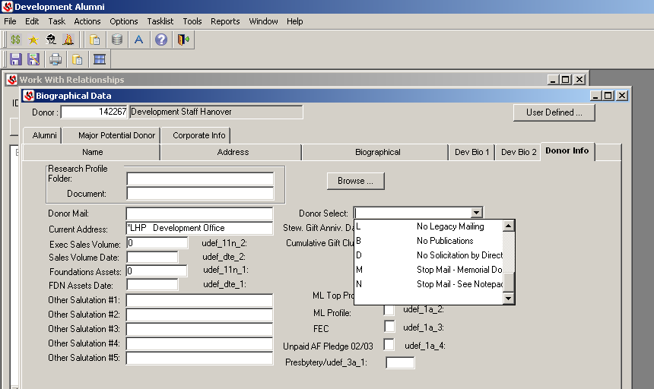
Stop or Receive Mailings/Mailing List
Check with Mike on this update
To Stop E-mail Updates: SEE SPECIFIC INSTRUCTIONS FOR EMAIL UPDATES!!!!!
- Right click on person’s name and go to Biograph Information
- Click on User Defined in top right corner
- Under E-NEWS Opt Out, there is a box that has UDef_1A_4 beside it. Below that are letters indicating the varying types of news. Choose the one that the person does not want to receive and type the capital letter into the UDef_1A_4 box. If there is more than one thing that the person does not want to receive, type the second capital letter into the box with UDef_1A_5.
To Receive E-mail Updates: SEE SPECIFIC INSTRUCTIONS FOR EMAIL UPDATES!!!!!
- Make sure that there are no capital letters typed into the UDef_1A_4 or UDef_1A_5 boxes. Also, make sure that the e-mail is accurately typed into their record.
To Stop Regular Mail Updates
- Right click on person’s name and go to Biograph information.
- Click on Name Tab
- Below Owner in the lower right hand corner there is a box that says Stop All Mail. Check this box.
- If the person wants to stop a specific type of mail, go to their Attributes section. Delete the row of the mailing they wish to stop receiving. The code DEFOCUS stands for “FOCUS” mailing list.
To Receive Mail Updates
- Make sure that the Stop All Mail box under the Name tab in the Biograph Information is not checked. Also, make sure that their address is correct.
- Under the Attributes section, add a row and add the type of mailing list that they wish to receive. See number 4 on the section above titled To Stop Regular Mail Updates to see some different codes for some mailing lists.
- If there is not a record in the system, create a new record and then add the attribute for the mailing list. Make sure to also put their Giving Relationship as “Other Friend” when creating the record.
To Receive Specific Updates
- Go to Donor Info tab
- Donor Mail dropdown code choices such as the Hanoverian, Electronic Hanoverian, etc.
  - To be added to specific mailing lists

Returned Mail Procedures
Campus Mailroom-Current Procedures
-The campus mailroom receives a bundle of returned mail each day from the post office.
-Each piece is analyzed and the originator is identified using the following method:
1. Department Number in top left corner above the return address
2. Department Name in the return address
3. Originator’s Name (requires opening mail piece)
-Each piece is counted and recorded along with the appropriate returned mail charges below:
$.49 each- BRE’s (Business Reply Envelopes)
$.34 each- BRC’s (Business Reply Cards 4.5” x 6” to 3” x 5”)
No Charge- first class or standard bulk mail with no ancillary endorsements
$.50 each- first class mail with “Address Service Requested”
$1.02 each- standard bulk mail with “Address Service Requested”
$2.82 each- standard bulk mail flat 3oz with “Address Service Requested”
-The returned mail is then redistributed to the Development Office by area or BRE address:
-Monthly total is submitted to Business Office on Business Reply/Postage Due charge slip and appears on the monthly budget report as line item “Returned Mail” but does not appear on departmental budget reports
Advancement Office Individual Department Area Procedures
-Track the cost of returned mail by reason for return utilizing Excel spreadsheet provided
-Analyze the reason for the returned mail to fix problem and reduce cost to budget
See Most Common Reasons of Returns in Return Mail Procedures Guide for assistance
See Also Guidelines for mailing/designing mail pieces from USPS
Utilize Resources and contact information for further assistance
-Submit spreadsheet monthly to Development Services and include Mail Piece Breakdown for further cost savings analysis
-Take appropriate action which includes:
1. Bad or updated addresses- send to Development Services for correction
2. Incorrect mailing lists- send to Development Services for correction
3. Design adjustments- contact designer or appropriate resource for assistance
Returned Mail
- ID Search *use search tips such as wild cards and address search through infomaker.
- Address tab –update address if provided by post office
- Address tab –enter date confirmed as data entry date and source as P for Post Office
- Address tab –status = P for 1st Postal return and L for 2nd Postal return
  - Do not code L (lost) based on return –or other 3rd class mailings –code as P
  - BLANK out *LHP address, city, state, zip and country on ALL L (lost) status
  - Do not delete addresses when they are P status
  - If previously coded as lost but no date confirmed or source then treat as 1st Postal Return
- Dev Bio 2 tab: Notify Solicitor of Lost addresses for assistance in obtaining updated information
- Right Click to Notepad: Add action of Email or Letter for follow up to get updated information
  - Add email action ONLY if there is an email address!
  - Add letter action ONLY if post office gave good address

FOLLOW UP
- Notepad action will send an email or a letter to the record holder notifying them that we received an address update and would like them to provide additional information to completely update the record. Daily procedures will be run by the assistant to generate the email and letters.
- Once a month, report of LOST records will be run and internet and records searches will be conducted to locate information for updates.

Notepad: Formatting & Coding
Formatting and Coding for Contact Reports
All NOTES entered into Jenzabar notepad should include the following coding system.

Every notepad entry will begin with a code and then your initials.
EX. CALLM DW –Called congratulating Joey on his acceptance.
CALLM – For all calls made to the student
CALLR – For all calls received
EMAIL S – For all emails sent
EMAILR – For all emails received
FACEBOOK – For all facebook correspondences
LETTER- For all letters sent excluding regular letterflow
GENERAL-For all other notes
VISITON- For all on campus visits
VISITOFF- For all off campus visits
SOLICIT – for annual or major gift solicitations. Can be used in conjunction with another contact code

For other notes:
ORG – for listings of constituent’s organizations, activities, awards, and honors
NEWS – for adding news articles where the constituent is mentioned
SPEAKER – for adding information about a constituent participating in a class, workshop, forum or speaking on campus. Also can be used in conjunction with other codes. Ex. E-mails about someone being a speaker.
PREVIOUS DEV PRES NOTE – for old President’s notes after new ones have been added

CODE
Completed by: First initial and full last name of person completing action
Date action was completed
Entered by: First initial and full last name of person entering note if different from above
Body of note

Examples:
CALL
Completed by: J Bryant
3/13/2009
Called to schedule a visit with Mr. Smith while Joy is in Indianapolis next week. He will check his schedule and get back with me.

OFFVISIT
SOLICIT
Completed by: CSchwing
3/13/2009
Entered by: KHatton
Met with Mr. Smith in his office in Indianapolis. He works for the largest law firm in the state and is on track to be made a partner in the next year or two. Explained the Anderson Challenge and asked Mr. Smtih to consider increasing his annual $1,000 gift to $2,500. He agreed and wants a reminder in June.
Follow-up: Pledge for $1,500 needs to be entered with a reminder date of June 1. Send follow-up thank you letter.

Notepad: Adding Actions
Adding Actions
- Right Click on Name and choose Notepad
- Check to see if action already exists in list on the right of the screen
  - If it does, STOP. Do NOT put duplicate actions in a record as it will cause duplicate rows in reports.
- Expand the list of actions by clicking on the + next to Actions
- Scroll through the list to find the Action code you are adding
- Change the New Items Start Date to the date of the action
- Drag the Action code to the right window

- Click save and then close the Notepad window.

Notepad Actions for Updates:
You will add 1 of 2 Notepad actions anytime a record is updated or changed and complete information is not received. For example an address update is received but no phone number or a business is listed but no update received. Actions will NOT be added to DECEASED records and Letter Actions will NOT be added to LOST records. Use best judgment to place an ACTION.

Email or Letter Action will be added to the individual record at the time of update. This action will send an email or a letter to the record holder notifying them that an address update was recieved by our office and we need them to provide additional information to completely update the record.

Daily procedures will be run by the assistant to generate the email and letters. Student will only add the actions and not the daily procedures.

Notepad: Adding Events

* Currently not used at SWU
Adding Event Attendance
- Check to see if the person you are registering has a spouse.
  - If the person has a spouse in the same class year, ensure that you are placing the event information on the Family ID holder.
  - If the person you are registering and the spouse have different class years, place the event information in the record of the primary person for the event. Example: if it is a reunion, put the information in the person’s account whose reunion they are attending. Otherwise, put the information in the family ID holder.
- Right Click on Name and choose Notepad
- Check to see if event already exists in list on the right of the screen
  - If it does, go to #8. Do NOT put duplicate events in a record as it will cause duplicate rows in reports.

- Expand the list of events by clicking on the + next to Events
- Scroll through the list to find the Event code you are adding
- Change the New Items Start Date to the date of the event
- Drag the Event code to the right window
- Highlight the new event line and click item details

- Go to the User Defined Tab
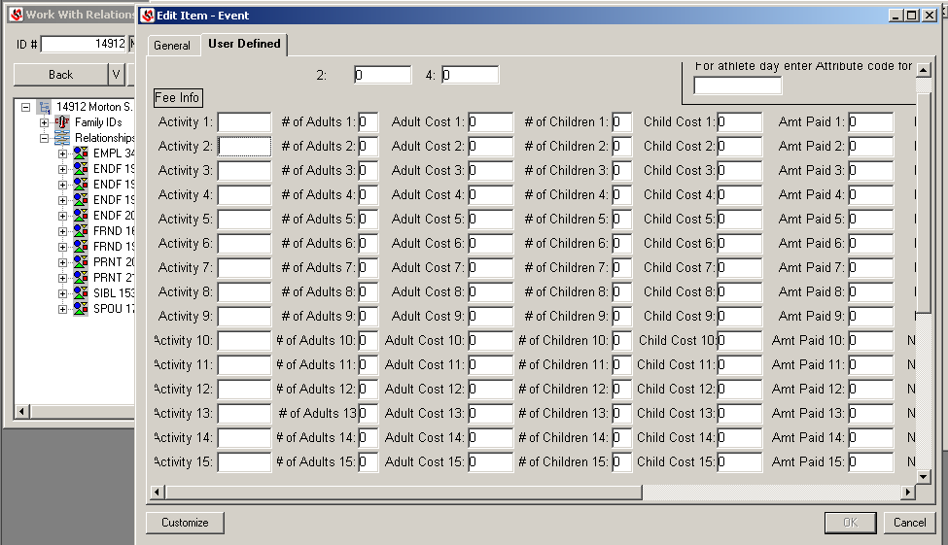
- In Activity 1, type the code for the sub-activity. (See Alumni Office’s code sheet) It is important that these be exactly the same every time as reports will pull based on that code.
- In # of adults 1, type in the number of adults attending the specific sub-event.
- In Adult cost 1, type in the total cost for adults for the sub-event. The field will not do the math automatically.
- In # of Children, type in the number of children attending the sub-event.
- In Child Cost 1, type in the total cost for children for the sub-event. The field will not do the math automatically.
- In Amt Paid 1, type in the total paid for the sub-event.
- In Notes 1, type any notes about the specific sub-event. Examples: if it is a luncheon and someone wants to sit at a specific table, or has a special request for that event.
- Repeat steps 10 through 16 for each sub-event.
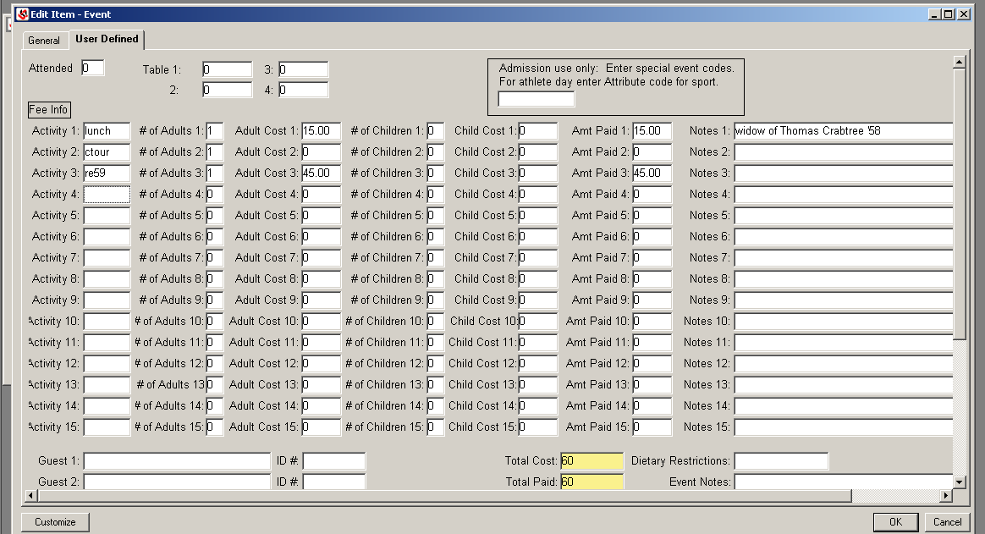
- If there are guests coming, scroll to the bottom of the form and type in the guests name exactly as it should appear on a nametag.
  - If the guest also has a Jenzabar record (if it is two alums attending an event together, see #1 as to which should be the guest and which should be the event holder.)

    - In the ID# field, type the ID number of the guest. This is important as it will keep the person from appearing on lists more than once. If you accidentally type an ID# and do not want it, you cannot delete the number. Instead, replace it with a zero (0).
    - In the guest’s Notepad, add the event by following steps 2 – 7. Do not add item details to the guest’s event.
- Repeat step 18 for each guest. The Total Guests field will automatically count the guests plus the main person.
- If there are dietary restrictions, type them into the corresponding field.
- If there are overall notes for the event, type them into the Event Notes field. Examples: if someone attending needs wheelchair access.
- Check to ensure that the Total Cost, Total Paid, Total Due, and Total Guests are correct.
- Click save and then close the Edit Item – Event window.

Relationships

Building a Relationship
The relationship has to do with the owner of the record. Determine how the ID number of the individual or organization relates to the record being worked on.

- Enter the ID number of the record
- Right click to Select Relationships
Warning: Make sure you select Relationships and NOT Giving Relationships
- Right click on a line in the Relationships screen
- Select Add Row OR Use the short-cut method of Ctrl+Shift+A
- Enter the ID number of the individual or organization that is to be related to the record being worked on in the Related ID number field.
- Select the relationship from the drop-down box.
WARNING: Remember that the relationship is determined by how the individual or organization record ID relates TO the record that is being worked on.
- Skip the Begin Date of Relationship field
- Skip the End Date of Relationship field
- Skip the Attitude Code field
- Skip the Notation field *script automatically adds this information at night
- Skip the Corresponding Relationship Notation field *script auto adds this information at night

STEP BY STEP: Adding relationships:
Right click relationships on tree
Right click to add row
Choose appropriate relationship code
Reads backwards “Walter Mann ID 26569” is “PRNT Parent of” ID# 202339 Charlene Mann
Note is always about record ID # and Corresponding Relationship Notation is other ID

Dup Records
DUP RECORD (duplicate records procedures)
First identify if actually duplicate record or not. Must pay attention to EVERY detail of records when comparing and deciding if duplicate record or not. Look at spouse info, look at notepad entries, look at address histories. Possible situations that would not be a DUP record include, father/son with same name and address – create relationship don’t DUP.
If DUP then proceed with instructions below. ASK questions if needed
- GOTO Name tab and add “DUP –use123456“ to beginning of last name or business name (IMPORTANT: Enter DUP, then put a Space between DUP and the – and then add the correct ID #)
- Enter for STOP ALL MAIL
- Delete Prefix, Suffix and Joint Prefixes
- GOTO Bio Info – Biographical tab
- GOTO Bio Info – Address tab and blank out *LHP address, code L for Lost
- Add date confirmed as date of update on *LHP
- Right Click to Delete any other addresses in Address Tab (*EML, BUS, WIN, SUM, etc.)
- GOTO Dev Bio 2 tab and MOVE solicitor ID to KEPT record if needed then Delete from DUP
- GOTO Salutations – MOVE to KEPT record if needed then Delete all from DUP record
- GOTO Attributes – MOVE to KEPT record if needed then Delete all from DUP record
- GOTO Relationships – MOVE to KEPT record if needed then Delete all from DUP record
- GOTO Donor Info – Tell DE Assistant to void and move gifts from DUP to KEPT
- GOTO Notepad – enter DBNOTE stating DUP with record name and ID of KEPT record

Basically you want to MOVE all of the information from the DUP record to the KEPT record then delete it from the DUP record and make a note of it in notepad. Admissions has permission to purge inquires as needed for those that are duplicates. All other departments must follow these steps for dealing with duplicate records.

Retired
Retired Update
- HR record check with assistant before updating! SEE HR RECORD UPDATES for more info!
  - If told that you can update the record, change giving relationship default to Retired or Emeritus by adding row. Do not delete the other giving relationship(s). Note: Default is hierarchy of closest relationship to the college
  - Be sure to go ahead and check if there is a family ID and if correct salutations (INF, FRM, LBL).
  - Do not change over the record from HR to DE!
- DE Records
  - Dev Bio 2 tab, add retired to Job Title
  - Address tab:
    - Move info from BUSINESS ADDRESS (BUS) to Former Business (BSF) by adding row. Delete Business Address Row.
    - Delete Business e-mail if listed. Add date confirmed and source of update.

Creating a New Record
Click on Joe Cool Guy
Right Click on ID# space. Click on Advanced Search
Type person’s last name and first name, enter. If nothing comes up try checking with Birth Date or any other information you may have.
Always check the names on the search so we do not have duplication of names. You can click on the Show detail to see the addresses. After Carefully checking system various ways you will then click on the Add Name tab.
Enter person’s Last Name, First Name, Middle Name, then press save.
You will then get the Duplicate Name Search Screen. Review all names on list before clicking on the No-Match-New ID tab. Once you click the No-Match- New ID tab the system will assign an ID number. Write the ID number on card/paper you are entering. Close out windows to return to Maintain Candidacy Screen. Enter ID# press Enter. Make sure the ID Number you enter is for the correct person. IF so key in information.

Maintain Candidacy Screen Name Tab
Birth Name = Maiden Name for person that is married.
Preferred Name = If you do not know the preferred name key in the person’s first name.
Status – C for Presumed current.
Current: should always be *LHP Legal/home/permanent adr DO NOT CHANGE THIS
Email = You can enter students primary email here

Prefix = Mr. or Ms if marked on card
Suffix = Jr. or Sr. II etc
Format = M for Personal/ middle initial
Mobile Phone = Enter Cell / Mobile number here
Owner = Department working with person’s file.

Go to address tab
Address Tab
Code: *LHP Legal/home/permanent adr
Street = Type in person street address do not abbreviate. Everything must be spelled out except PO Box
City/State/Zip = State is the only abbreviation
Country= Enter the Country code or US if in US.
County= Anywhere in SC you will need to key in the county code. (Use the two digit codes) Look this information up in the State and County Codes Book or USPS.com
Status = C Presumed Current
Date Confirmed = today’s date
Number / Ext= Phone number with Area code. Save information.
To enter the email address
Right click on the gray area and click on add row. Check the Email box

Code = EML Email Address from the pull down menu.
E-mail: = Enter email address
Status = C Presumed Current

Save and go to Biograph Tab

Biograph Tab
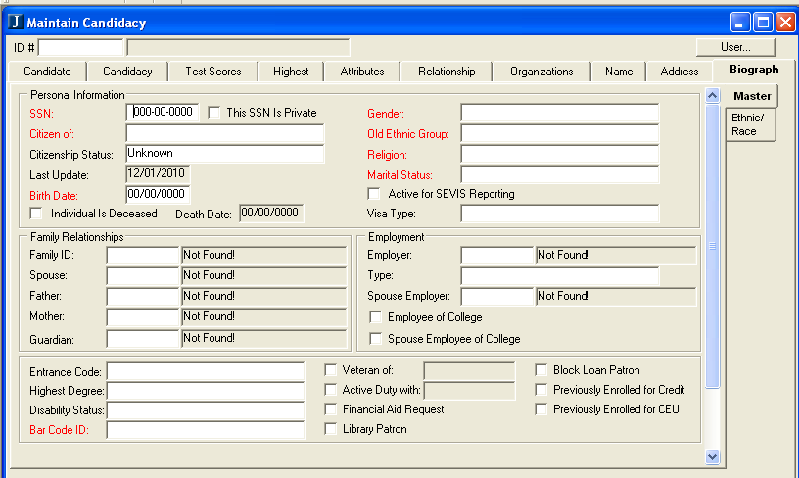
SSN= Key in SS number and check the This SSN is Private. Always check the This SSN is Private if you key in SS number. Do not enter SS for Canada or other international person.
Citizen of = Do not guess at this. Put whatever they have or leave blank
Citzenship Status = if US put Citizen of US if not a US citzen then leave as Unknown.
Birth Date = two place month and date and four place year. (Exp. 01/01/2006)
Gender = Put whatever they have or leave blank
Ethnic Group = Leave blank and use the Ethnic / Race Tab. See notes below
Religion = whatever they have or leave blank
Marital Status = Put whatever they have or leave blank
Ethnic / Race Tab = Click Add Row, Once you add the row you will then be able to choose the drop down menu for Ethnic choose whichever applies then choose the Race that applies. Save and go back to the Master tab before going to the Candidate Tab

Married and Divorced Updates
Updating to a Married Record *SEE UPDATING RECORDS FOR SCREENSHOTS AND OTHER INFO
- IF PARENT or MEMORIAL DONOR – See creating new parent or memorial gift records
- Right Click Biographical Info and GOTO Name tab
  - Move Last name to birth name (if birth name already filled – do not delete)
  - Enter new married name into Last name field as requested!!
    - May take married name or may not. May keep birth name plus married name with dash or not.
    - Make notepad entry for special requests that are not the standard
  - Change prefixes as needed
  - GOTO Address tab: Update with new information if provided with Date Confirmed and Source
- Update Family ID in Family relationship field. Go to Biographical tab.
  - Record with highest giving relationship is Family ID
  - If both spouses are alums and have their own records then the family ID goes to the male record ID number.
  - Spouse ID=Spouse record ONLY if alumni and has own record ID number
- GOTO Dev 1 tab update Career Type *if provided then Dev 2 tab update Job Title *if provided; Close window
- Right Click to Salutations – update accordingly
  - Both alums – Male alum record Female alum record
    - INF= John INF= Mary
    - INS= John and Mary not needed
    - FRM= Mr. Smith FRM= Mrs. Smith
    - FRS= Mr. and Mrs. Smith not needed
    - LBL= Mr. and Mrs. John Smith not needed
  - No spouse as alum or with a record – Male or female record
    - INF= John INF= Mary
    - FRM= Mr. Smith FRM= Mrs. Smith
    - LBL= Mr. John Smith LBL= Mrs. Mary Smith
  - Alum spouse or spouse with own record – LBL goes to highest giving relationship
- Right Click to Attributes – Add spouse first name if non alum (DSPNM) *if info provided
- Right Click to Relationships – Add spouse if alum or a record holder (SPOU) *if info provided
  - Update Spouse record as appropriate; salutations, status, prefixes, address, family id
Updating a Divorce
- Right click to Biograph Information and GOTO Name tab.
  - Divorced female: change the former married name back to the birth name.
    - This is on a case by case basis! Needs to change to whatever the update says!!
    - May take married name or may not. May keep birth name plus married name with dash or not!
  - Change the prefix and joint prefix to Ms. instead of Mrs.
    - Sometimes we find out when they marry someone else, so update accordingly!!
  - Divorced man: you only have to change the joint prefix to Mr.
- GOTO Address tab. Make the necessary Address and E-mail updates *if provided. Otherwise, leave them alone!
- GOTO Biographical tab.
  - Change the marital status from married to divorced
  - If both are alums, then change the family ID’s to their own record id and delete the Spouse ID.
- Right click to Attributes. If non-alum spouse then delete DSPNM and add new DSPDV (divorced spouse non-alum)
  - Add children/step children, grandchildren, great grandchildren to spouse record of divorced alumn.
- Right click to Relationships. If both alums then delete the SPOU relationship and add new FMSP (former spouse)
- Right click to Salutations. Delete any INS and FRS and add LBL appropriately.
  - If re-married with new spouse having own record then update INS and FRS as well as LBL accordingly

Deceased
Making a Deceased Record –
- GOTO Giving Relationship
  - Parent or Memorial Records: Don’t mark Deceased if shared record - see further instructions for Parents
  - If spouse has their own record than mark Deceased as normal and see Spouse subsection for further instruction

- Right Click to Biograph Info – GOTO Biographical tab
- Enter for DECEASED record *MUST have date of death entered-DO NOT enter 01/01/00 unless ok by assistant.
  - Go to http://ssdi.rootsweb.com/ for search of DOD. If it is not listed there, check local newspapers where the person was from and see if you can find an obituary of the person. Print obituary and forward to alumni and pr
- Delete spouse ID in family relationship field or make spouse record holder if the deceased was the Family ID
  - The screen shot above shows spouse already deceased (he was widowed) so family id already record holder.
- Deceased record ID# is always Family ID# and you always delete the spouse ID!
- GOTO Address tab and add row for DEA (Deceased) address
  - Copy *LHP address into DEA address
  - Blank out *LHP address
  - Add date confirmed as date of update to both DEA and *LHP
  - Add update source as P=Post Office or I=Individual as applicable
  - Delete any email addresses in Address Tab (*EML, EMB, EM2, etc.)
  - Add DEB (Deceased Business) address if needed and delete Business address; add date confirmed
- GOTO Name tab and change “Addresses: Current” to DEA
- Enter for STOP ALL MAIL
- GOTO Dev Bio 2 tab and remove solicitor from record and notify them of the death
- Close Biographical Data Window
- *Make sure when someone is deceased that you keep their giving relationship
- Right Click to Salutations – Delete LBL, INF, FRM, INS, FRS only! Do not delete PRA, PRF, PRP, or APR.
  - Any other salutations: contact the person that maintains the salutations to decide whether to delete or not.
- Right Click to Attributes – Find spouse if listed (may have own record instead of attribute if so see subsection below)
  - determine if the spouse needs their own record (see non alum spouses of deceased alumn for more info)
    - yes, if the deceased was a donor (check in Donor Inquiry) and active with college (by attributes)
  - Kids leave as is - in attributes and relationships
- Right Click Relationships – Find spouse (SPOU) if listed and delete. Add relationship - Widow(er) (SPSW)
  - If spouse already deceased then keep relationship the same.
  - TRST relationship – update Trust record as appropriate, remove deceased spouse from the record and salutations
  - Delete EMPL (Employer of) or EMPY (Employee of) if listed
  - Kids leave as is - in attributes and relationships

Deceased Alum’s Spouse with his/her own record
- GOTO Spouse’s record
- Right Click to – Name tab and change prefixes as needed
- Right Click to – Biographical tab and change marital status to widowed
  - Family ID-delete deceased alum’s ID and insert Spouse ID (record holder) as Family ID
    - Record holder ID# is always Family ID# if alum’s spouse is deceased, and always delete the spouse ID!
- Right Click to - Salutations – revise as needed (INS and FRS delete)

Deceased Parent’s Spouse without own record (Change record from one spouse to the other spouse)
- Right Click to Bio Info – Name tab
  - Change Name info from Deceased parent to Living parent info
- GOTO– Address tab
  - Delete Deceased’s Business Info, etc. as needed
- GOTO – Biographical tab
  - Change Prefixes if needed and Marital Status to Widow(er)
  - Change Gender to appropriate
- GOTO Dev Bio 1 and Dev Bio 2 –Delete Deceased’s info as needed
- Right Click to Attributes
  - Add (DSPDC-Non Alum Deceased Spouse) regardless of Alum or not – add class yr if Alum and DOD
  - Delete (DSPNM-Non Alum Spouse)
- Right Click to Salutations
  - CHANGE all as needed: Salutations INF, FRM, LBL, etc.
  - Delete (INS and FRS)
- Right Click to Relationships
  - RE Owned, Current Students only: Notify Summer Hawkins of the death and forward copy of information to her.

Death Notification of Alum’s – Send notification to other departments per instructions below:
- Public Relations – Janelle Beamer
- Alumni Office – Joy Bryant (Will scan obituaries – and send copies if provided)
- Planned Giving Office – Jim Wiggins
- Development – Mary Costello and Melissa Childs
- Check ‘Notepad’ for obituary (DE assistant will add electronic copies of obituaries to notepad when provided)

DEPARTMENTAL COLABORATION FOR Non-Alum Spouses of Deceased Alums
Deceased Alum’s Spouse without own record
- Determine if we need to keep relationship with deceased alum’s spouse
  - Check to see if current or recent donor (donor inquiry) to continue to solicit
  - Check to see if active on campus (attributes) to continue to receive campus mail
- If yes: Create a new record for spouse (see create a new record for specific instructions)
- Add giving relationship of WA (Widow of Alum) or FW (Faculty/Staff Widow(er)) as appropriate
- Add relationship of SPSD-(Deceased Spouse of)
- Add attribute of DWACY (Deceased Alumn Spouse Class Year ____)
- Add “all publications” on Donor Mail field in Donor Tab
Departmental Action items:
- A giving relationship of AW will need to be created. Chris will coordinate this with Dawn.
- An insert will be placed in the reunion packets sent out by the Alumni Office asking if anyone knows of any non-alum widows/widowers who would like to still receive Hanover mail.
- A blurb will be placed in the e-newsletter and Hanoverian asking if people know of non-alum widows/widowers who would like to receive mail. Ann will coordinate this with Eric.
- Ann and Darlene will start making a list of spouses that they personally know need to have separate records created.
- Chris will create a list of accounts that have no class years linked to deceased spouses with class years.
- Chris will check with Dawn to see if there is a way to retroactively (easily) give the new spouse record soft credit for gifts that the alum has made.
- Chris will modify all necessary reports to include AW’s in the friends category.

SUMMARY:
When we receive notice that alum has passed we will look in the obituary if available or in Jenzabar attributes for the name of a non-alum spouse. The non-alum spouse will be given a new record with the giving relationship AW. The relationship to the spouse will be built. An attribute will be placed in the new record with the class year of the alum spouse.

Two different sympathy letters will be created in the alumni department – one for alum spouses and one for non-alum spouses. A separate solicitation will be done annually for widows/widowers of alumni. AW’s will be included in their spouse’s class year for invitations to events and reunions.

If a non-alum spouse continues to give to the College, their gifts can be put into class specific funds and can be in memory of their spouse or in honor of their spouses class year. However, the gift cannot count in the numbers of donors for each class. For reporting purposes, an AW will be counted with friends. If the alum was a member of the Presidents Club, those attributes will be copied into the non-alums record.

Family ID and Spouse ID
Updating Records
Family Relationships: GOTO Biographical tab.
Family ID= Owner Record
  - If both spouses are alums and have records then the family ID is the male record ID number.
Spouse ID=Spouse record ONLY if alumni and has their own record ID number (make sure there is a relationship created between records. See relationships for more info.
If deceased record then make record holder the family ID and delete spouse ID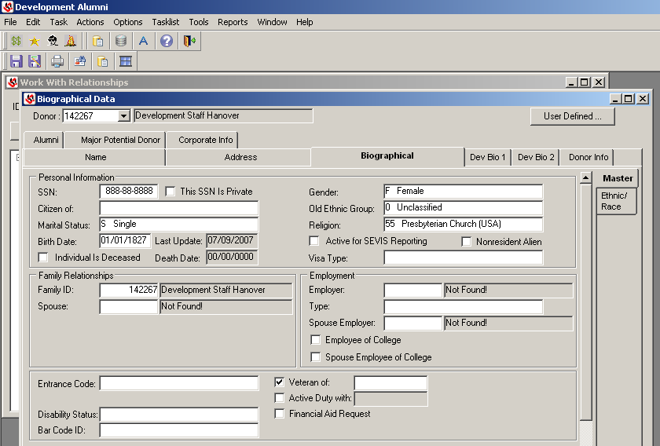
Create a New Record
- GO TO Biographical tab and enter new record holder ID# as the Family ID.
  - IMPORTANT: Every record must have a family ID to be included in reports!
  - Enter spouse ID if known (don’t forget to create the relationship)
  - Do not enter father, mother, and guardian family relationships. These are not used!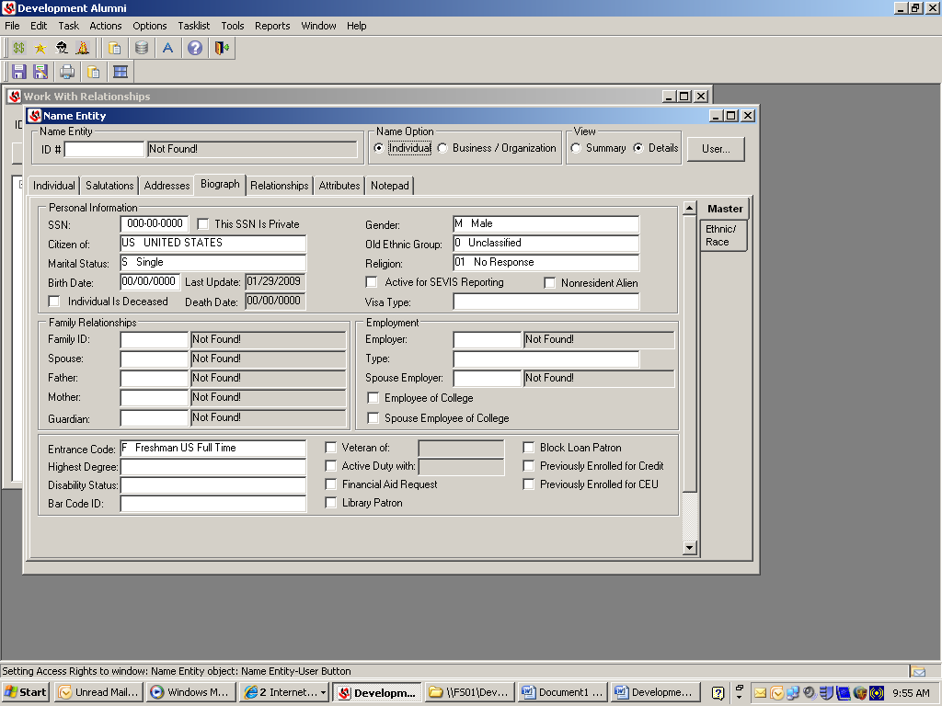

DUP Records
Delete family ID and spouse ID in family relationship field

New Parents or Memorial Donor Records
Go to Biographical tab:
- Family ID= Owner Record
  - If both spouses are alums and have records then the family ID goes to the male ID record ID number.
- Spouse ID=Spouse record ONLY if alumni and has own record ID number
Married/Divorced Records
Married
- Update Family ID in Family relationship field. Go to Biographical tab.
  - Record with highest giving relationship is Family ID
  - If both spouses are alums and have their own records then the family ID goes to the male record ID number.
  - Spouse ID=Spouse record ONLY if alumni and has own record ID number
Divorced
- GOTO Biographical tab.
  - If both are alums, then change the family ID’s to their own record ID and delete the Spouse ID.
DECEASED Records
Go to Biographical Tab
- Deceased record ID# is always Family ID# and you always delete the spouse ID!
- Delete spouse ID or make spouse record holder if the deceased was the Family ID

Deceased Alum’s Spouse with his/her own record
- Go to Biographical Tab
- Family ID-delete deceased alum’s ID as family ID and insert the Spouse ID (record holder) as Family ID
- Deceased record ID# is always Family ID# and you always delete the spouse ID!

Trustee Records in Jenzabar
Trustee records will be maintained by Development

