Data Entry Standards: Jenzabar EX

Southern Wesleyan University
Revised May 19, 2015

- General
  - Purpose
    - This document has been compiled to address common standards to which all departments must adhere when entering or changing data in the Jenzabar EX application or database.
    - This document does not address data entry standards in any other applications besides the Jenzabar EX application.
    - This document is not a “How to Use Jenzabar EX” guide. It strictly addresses the standards for data entry.
    - Common “modules” addressed herein:
      - Name
      - Address
      - Biograph
      - Notepad
      - Attributes
      - Relationships
      - other?
    - Department-Specific Standards:
      - Department-specific standards will/may be maintained separately from this document.
      - Department-specific standards must comply with the standards presented in this document.
  - Target audience
    - New employees who will enter data into the Jenzabar EX application.
    - Any employee responsible for entry or maintenance of data in the Jenzabar EX application.
    - other?
  - Review
    - This document and these standards will be reviewed annually [around what time of the year?].
  - Data Ownership
      - Who owns data?
      - Who changes data?
  - Abbreviations
    - To be discussed….
  - Spacing
    - To be discussed….

- Duplicates
    - To be discussed….

- Names (The tab name is usually labeled “Name” or “Individual”.)
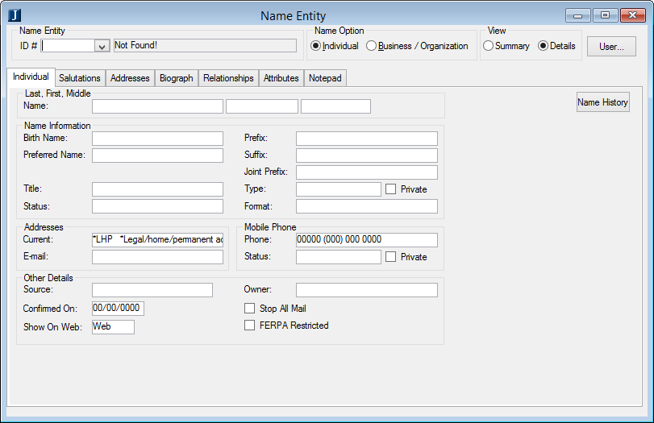
  - General
Please review this section, copied from CCU Standards document:
    - Before entering any person or business into the database, carefully check to make sure that the entity you are entering is not already in the system. (See the section on “Duplicates” for details.)
      - Duplicate Example 1: There are three records for one person with different variations in the spelling of their first name (Christine, Christina, and Christie), but they are all the same person.
      - Duplicate Example 2: If the first name you get is a derivative of a name (e.g., Bob instead of Robert, Liz instead of Elizabeth, etc.) check to see if someone in the system has the full version of that name in your search for duplicates.
    - Always double check name spellings.
    - Names are to be typed using Proper case.
    - Names are never to be typed in all upper case or all lowercase.
      - EXCEPTION: A business whose name is an acronym (e.g., AARP).
    - Punctuation
      - Names are only to have punctuation when it is part of their legal name.
      - Names are never to be entered with periods, even when it is an initial.
      - Hyphens and apostrophes are acceptable.
      - Names are never to be entered with diacritical marks.
        - Examples: ä, á, ą, ć, ç, é, ê, í, ü, or any other accent marks not listed here
    - Name Format should be entered according to that person’s preference.

  - People (Individuals)
    - Name Information Section
      - Last, First, Middle Name
        - Enter the full legal name as it appears on the person’s Social Security Card.
          - If at all possible, be sure to gather the full legal name of the individual.
          - Do not enter preferred names in these fields—legal name only.
          - Do not enter nicknames in these fields—legal name only.
          - Do not enter Suffix or Prefix in these fields. (Use the designated fields for these.)
          - NOTE: The legal name is used for password resets and other verification, so it is important that this data is entered correctly.
        - Do not enter any punctuation except for hyphen or apostrophe.
          - When are hyphen and apostrophe acceptable?
          - Do not enter a period (“.”) in any name field for individuals.
        - Middle name should be full middle name to help prevent duplicate records. If no full middle name is provided, enter the initial.
        - Proper Case Example: Entry of names like “McCloud” or “MacHenry”?
NOTE: Need to come back and address International student names.
NOTE: The name in PowerFAIDS overrides the name in Jenzabar when transferred from PowerFAIDS to Jenzabar.
      - Birth Name
        - Enter the Maiden Name of the person.
      - Preferred Name
        - NOTE: This is a KEY field for creating student and other accounts. The Preferred Name is part of the person’s account ID as well as the person’s email address.
          - Account Names follow the standard of PreferredName+LastName (e.g., “AlexSmith”, “MaryJones”).
          - Email Addresses follow the same standard with “@mail.swu.edu” appended.
        - If a person wishes to go by a name other than his or her legal first name, the First Name field must still contain their legal first name and only that.
The Preferred Name field is where other names go.
        - No Preferred Name Specified
          - If a preferred name has not been provided, enter the first name into the Preferred Name field. (Required)
        - Derivative Name
          - If any person wishes to go by a derivative of their legal first name (e.g., “Rick” instead of “Richard”):
            - Enter his or her entire legal first name into the First Name field.
            - Enter the preferred derivative name in the Preferred Name fields.
        - Middle Name
          - If any person wishes to go by their middle name:
            - Enter his or her entire legal first name into the First Name field.
            - Enter his or her middle name into both the Middle Name and Preferred Name fields.
        - Last Name
          - If any person wishes to go by their last name:
            - Enter his or her entire legal last name in the Last Name field.
            - Enter his or her first name in the Preferred Name field.
            - Enter his or her last name in the Nickname field.
NOTE: The Nickname field appears to have been removed from the Name tab. Was there a reason for this?
        - Indistinguishable/Inappropriate Names
          - If a person wishes to go by a name that is not a distinguishable part of their legal name (e.g., “Bubba” or “G-Dog” unless that is their real name), that name should only be entered in the Nickname field. It is not fit to be entered into either their First Name or their Preferred Name field.
        - Examples
          - Robert Smith prefers “Bob”
            - First name = Robert
            - Preferred Name = Bob
            - Last Name = Smith
          - John Paul Pennington prefers “Paul”
            - First Name = John
            - Middle Name = Paul
            - Last Name = Pennington
            - Preferred Name = Paul
          - John T. Doe prefers “JT Doe”
            - First name = John
            - Middle Name = T
            - Last Name = Doe
            - Preferred Name = JT.
          - Elizabeth Jones prefers “Baby”
            - First name = Elizabeth
            - Last Name = Jones
            - Preferred Name = Elizabeth
              - DO NOT put Baby in Preferred (we aren't going to send mail to a nickname like Baby).
            - Nickname = Baby
      - Title (optional)
        - There is no validation on this field, and it is currently not used.
      - Status
        - This is “C” by default (Presumed Current).
        - Other value is “O” (Out of Date).
          - Is this used to indicate an inactive person?
      - Prefix (Required)
        - Do not enter a period (“.”) in the prefix.
        - Prefixes are only to be entered into this field—never in the First or Last Name fields.
      - Suffix (optional)
        - Do not enter a period (“.”) in the suffix.
        - Suffixes are only to be entered into this field—never in the First or Last Name fields.
      - Joint Prefix
        - Used by Advancement and for Parent records.
      - Type
        - If known, please enter (see Human Resources or Business Office standards document).
      - Private
        - ?
      - Format
        - This is “M” by default for individuals (Personal / Middle Initial name format).
          - Name Format should be entered according to that person’s preference???
NOTE: If a person changes from, for example, a donor to a student, DO NOT ERASE DATA!
    - Addresses Section
      - Current
        - This is “*LHP” by default.
        - Not being used?
      - Email
        - This defaults to the “*EML” (Primary) email address entered in the Addresses tab.
    - Mobile Phone Section
      - Phone
        - Enter the mobile phone number of the individual, including area code.
        - What about international numbers?
      - Status
        - This is “A” by default (Active).
        - Other option is “I” (Inactive).
          - Is this used?
      - Private
        - ?
    - Other Details Section
      - Source
        - Not used?
        - What is this? (Current options are “1”, “4”, “D”, “M” and “S”.)
      - Confirmed On
        - Defaults to the current date.
      - Show on Web
        - This is “Web” by default.
          - Is there ever an appropriate time to choose “None?”
        - Options
          - Web – Web access for Students and Faculty – CRM portlets only
          - None – No Web access
      - Owner
        - This should be the department abbreviation of the employee entering the data.
        - Example: If Admissions is entering the data, this should be “AD”.
      - Stop All Mail
        - The owner of the record (see “Owner” above) is responsible for checking or unchecking this field.
        - This field applies to ALL mail for this person.
          - Only use this field for individuals who are requesting to never be contacted again.
          - If an individual requests a particular type of contact to be stopped, use the appropriate departmental “stop mail” flag instead of this one (e.g., stop mail only from Advancement).
        - Everyone must look at this when sending correspondence, to make sure individuals with this field set to “Y” are excluded from the mailing!
      - FERPA Restricted
        - This check box indicates whether this particular individual wants their education records and personally identifiable information protected under the FERPA guidelines.
        - If the check box is selected (= “Y”) the individual wants the FERPA protection.
        - If the check box is cleared (= “N”) the individual does not want to exercise their right to FERPA protection. The default value is “N”.
        - When should this be used?

  - Churches / Organizations
    - To be discussed….

  - Name Changes
    - To be discussed….
      - Reasons
      - Process
      - Acceptable Proof of Name Change
      - Other Name Change Issues
      - Other?

- Addresses
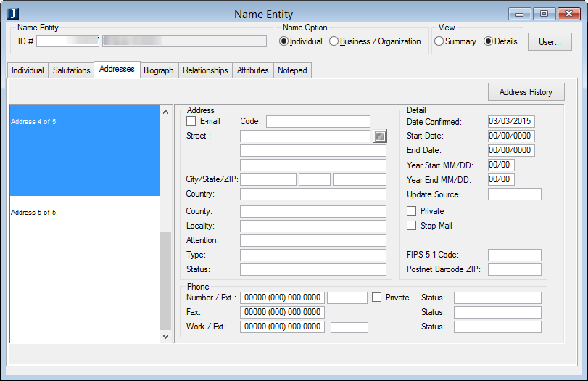
  - General
    - Addresses are to be typed using Proper Case.
    - Addresses are never to be typed in all upper case or all lowercase.
    - No punctuation should be included except for hyphens and apostrophes when part of the proper name (street, city, etc.).
    - Everything should be spelled out properly; there should be no abbreviations in addresses anywhere.
      - Exception: “Post Office Box” should be abbreviated to “PO Box”.

  - People (Individuals)
    - Address Section
      - Email checkbox
        - Check this box if the address being entered is simply an email address.
      - Code
        - Select the appropriate address code for the address being entered.
          - Common codes used:
            - *LHP – Legal Home Permanent: The person’s legal place of residence
              - NOTE: Every person should have a *LHP address (required), not just a summer address, parent’s address, etc.
            - *EML – Primary Email Address:
              - This is to store a person or business’s preferred or first email address.
              - If the person is a student, staff, or faculty of SWU, this MUST contain their SWU email address. NO EXCEPTIONS.
        - This field needs further discussion regarding valid entries, used/unused entries, etc.
      - Street
        - Divided into three fields: Address Line 1, Address Line 2, Address Line 3
          - Address 1
            - Street Address only, unless there is only a PO Box for an address
          - Address 2
            - PO Box if it is the only item included with a street address, OR…
            - Apt/Suite/Lot # if both a street address and a PO Box are included
          - Address 3
            - PO Box if both a street address and Apt/Suite/Lot # are included
        - Example 1
          - Address 1 Street Address 123 Main Street
          - Address 2 PO Box PO Box 87
          - Address 3 (left blank)
        - Example 2
          - Address 1 PO Box PO Box 123
          - Address 2 (left blank)
          - Address 3 (left blank)
        - Example 3
          - Address 1 Street Address 123 Main Street
          - Address 2 Apt # / Suite # / Lot # Apartment 4B
          - Address 3 PO Box PO Box 44
        - Example 4
          - Address 1 Street Address 1000 Rural Lane
          - Address 2 Apt # / Suite # / Lot # Lot 27
          - Address 3 (left blank)
      - City
        - Enter the full name of the city (no abbreviations).
      - State
        - Select the correct state from the drop-down menu.
      - ZIP
        - The 5-digit ZIP code should be used at a minimum.
        - If available enter the ZIP+4 code.
          - Format: 5 digits + hyphen + 4 digits (e.g., 12345-0001)
          - The ZIP+4 code is preferred in general, and is required for Development.
        - ZIP+4 may be required for bulk mailings. (RESEARCH THIS.)
      - Country
        - Select the correct country from the drop-down list.
        - This is required for ALL legal/mailing addresses (including US addresses).
NOTE: Need to come back and address International student names.
      - County
        - Select counties for South Carolina addresses only.
        - For non-South Carolina addresses, select the appropriate non-South Carolina county in the EX address. (This is a change from the previous procedure.)
          - You can look up the county for the address at https://tools.usps.com/go/ZipLookupAction_input, then
Currently, the online applications are designed to only allow applicants to select “96 Not SC” if a non-SC state is selected.
The applications need to be changed to allow non-South-Carolina counties to be selected.
Will investigate prefilling the county based on the ZIP code entered.
      - Locality
        - Not used?
      - Attention
        - Admissions uses this for PGDN addresses for names of parents.
        - Format follows standard specified for names (capitalization, punctuation, etc.).
Address Line 3 (ADDR3) is used for PGDN email addresses currently. This needs to be in a separate code/address record.
Module Managers need to address parent records and FERPA entry.
      - Type
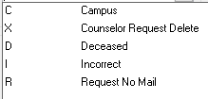
We discussed eliminating all of the above Type codes except for possibly “D Deceased".
        - Admissions is currently using “Deceased”.
          - Continue to use?
Possibly add a “deceased” stage code? Re-purpose stage code 99?
      - Status
        - Use in coordination with “Stop Mail” field to help explain why mail is stopped.
        - Codes
          - M – Mail Returned
          - N – obsolete
          - O – obsolete
          - C – Presumed current (default)
          - R – Requested removal / Opted Out
          - Add Deceased?
Possibly add a “deceased” stage code? Re-purpose stage code 99?

<pick up here>

    - Detail Section
      - Date Confirmed
      - Start Date
      - End Date
      - Year Start MM/DD
      - Year End MM/DD
      - Update Source
      - Private
      - Stop Mail
      - FIPS 5 1 Code
      - Postnet Barcode ZIP
    - Phone Section
      - Number / Ext
      - Private
      - Fax
      - Work / Ext
      - Status (one each for Phone, Fax and Work)
        - A – Active
        - I – Inactive

Copied and adapted from the CCU Standards document:

  - Business/Organizations
    - To be discussed….

  - Address Codes Defined
    - “*” Address Codes
      - These are some of the most important codes we use on a daily basis.
      - *LHP – Legal Home Permanent
        - Used for personal home addresses and for businesses as their main address.
      - *EML – Primary Email
        - This is to store a person or business’s preferred or first email address.
        - If the person is a student, staff, or faculty of SWU, this MUST contain their SWU email address. NO EXCEPTIONS.
      - *WRK – Work Address
        - DO NOT USE??? (Not used by CCU)
        - This has been used inappropriately to record the employer of the person, rather than their work address.
          - Record employer information in the Biograph tab—not here.
          - We need to

      - *CUR – Current
        - THIS CODE IS NOT TO BE USED TO DEFINE AN ADDRESS.
        - It is only to be used on certain screens to specify that a particular address, be it *LHP or PLCL, is their current preferred address at which to receive information.
    - Physical Address Codes
There are 4 main types of physical address codes: those for persons, businesses, our internal use, and organizations.
      - Person
        - *LHP – A person’s legal place of residence
        - PCMP – A person’s campus address
        - PDRM – A person’s dorm address
        - PEMG – An emergency contact address
        - PFTH – A person’s father’s address
        - PGDN – A person’s legal guardian’s address
        - PGD2 – A person’s legal guardian’s address
        - PLCL – An international student’s local or host family address
        - PMTH – A person’s mother’s address
        - PSMR – A person’s summer address
        - PSWK – A person’s spouse’s work address
        - PVCN – A person’s vacation address
        - PWK – A person’s work address
        - PWTR – A person’s winter address
        - BINV – A billing address.
        - A001 – Alternate mailing address
        - A002 – Alternate mailing address
      - Business
        - *LHP – A business’ primary / main office address
        - BALT – A business’ alternate address
        - BCHK – A business’ Accounts Receivable address (aka, Check Address)
        - BINV – A business’ Accounts Payable address (aka, Invoice address)
        - BPO – A business’ Purchase Order address (aka, Ordering Address)
        - BSHP – A business’ Shipping address
      - Internal
        - IFTR – Financial Aid Transcript return address
        - IMGN – “Our mag media address”
        - IRCT – Receipt Return address
        - IRTN – Our Return address
        - IRTR – Transcript Return address
      - Organization
        - *LHP – An organization’s primary / main office address
        - CHPL – Church physical address
        - OBRC – An organization’s branch address (not the main office)
        - OCMP – An organization’s campus address
        - OLCL – An organization’s local address
        - ONTL – An organization’s national address
        - ORGL – An organization’s regional address
        - OSTT – An organization’s state address
    - Email / Electronic Address Codes
      - *EML – Primary Email – This is to store a person or business’s preferred or first email address. If the person is a student, staff, or faculty of CCU, this MUST contain their SWU email address. No exceptions.
      - *SWU – Lifetime Email – This is to store a student’s lifetime email address. DO NOT MODIFY.
      - EML2 – Secondary Email – This is to store a person or business’s secondary email address.
      - EMLB – Business Email – This is to store a business’s email address.
      - TEML – Tertiary Email – This is to store a person or business’s tertiary email address.
      - SCRN – DO NOT USE
  - Physical Addresses
  - Email Addresses
  - Stop Mail Flags

- Biographical Data
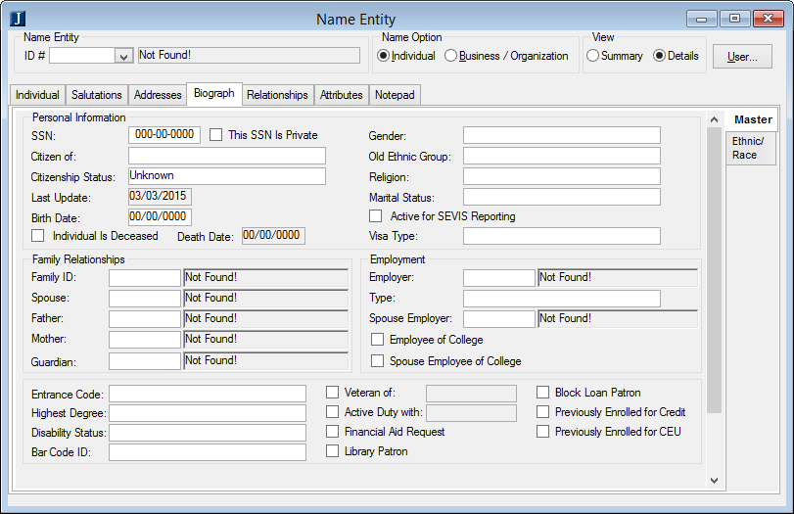
    - To be discussed….

